- Click “File” in upper left
- Click “Make a copy”
- Rename the document “Your Last Name and First Name NJHS” (so mine would be Kreiser Kendall NJHS)
- Complete the application
- When complete, click “File” in upper left
- Download as: PDF Document (.pdf)
- Attach the PDF to an email and send to knkreiser@dcsdk12.org

Mesa Middle School
National Junior Honor Society
Application Form

MEMBER INFORMATION SHEET

Name:
Grade:
Address:
City:
Zip code:
Home Phone Number:
E-mail address:
Parent/Guardian Name(s):
E-mail address:
* E-mail addresses will be used as group communication from the sponsor, regarding NJHS activities.

**The entire application packet is due to Ms. Kreiser NO LATER than Thursday, February 28th, 2018 at 2:45PM - NO EXCEPTIONS**

AFTER YOU SUBMIT YOUR APPLICATION, YOU SHOULD RECEIVE AN EMAIL FROM MS. KREISER CONFIRMING THAT SHE RECEIVED YOUR APPLICATION. IF YOU HAVE NOT RECEIVED AN EMAIL STATING THAT YOUR APPLICATION PACKET HAS BEEN RECEIVED WITHIN 24 HOURS, PLEASE WITHER EMAIL MS. KREISER OR SEE HER IN THE LIBRARY.

Mesa Middle School
National Junior Honor Society

Five National Junior Honor Society Traits

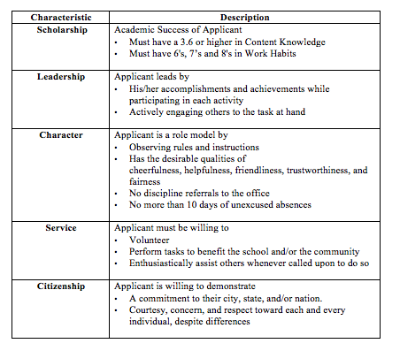
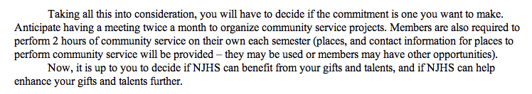

Mesa Middle School
National Junior Honor Society
Application Form

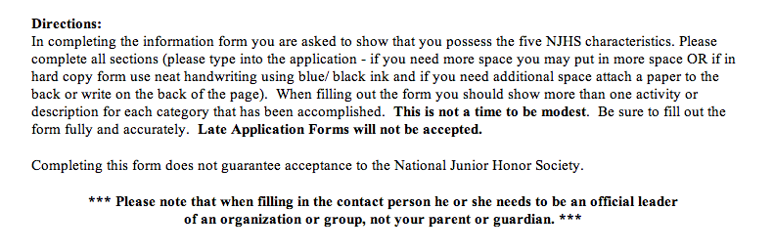
- Name of Candidate:

First Name:
Last Name:
M.I.

- Paragraph: In a brief paragraph explain why you would like to join the National Junior Honor Society. (Expand or contract the text box as necessary. If you have a hard copy you may type this paragraph and attach it to the application.)

- Co-curricular Activities: List all school activities in which you have participated during middle school (and late elementary school). These activities may include, but are not limited to, Band, Chorus, or EPub. Be specific about the role or position you had with this activity and include any special accomplishments. (Expand or contract the text box as necessary. If you have a hard copy you may type this section and attach it to the application.)

Co-curricular Activities | Grade of Participation (6th, 7th or 8th) | Accomplishment | Name and Phone Number of Official Contact Person

- Community Activities: List any community activities outside of school in which you have participated and include any major accomplishments in each. These activities may include, but are not limited to, sport teams, clubs or camps sponsored outside of school, or Boy or Girl Scouts. Please do not repeat any participation listed above. (Expand or contract the text box as necessary. If you have a hard copy you may type this section and attach it to the application.)

Community Activities | Grade of Participation (6th, 7th or 8th) | Accomplishment | Name and Phone Number of Official Contact Person

- Service Activities: List any service activities in which you have participated. These can be individual or group projects. Service activities are defined as activities done for others for which no compensation has been given. These activities may include, but are not limited to, religious service projects, family organized projects, or community organized service projects. (Expand or contract the text box as necessary. If you have a hard copy you may type this section and attach it to the application.)

Service Activities | Grade of Participation (6th, 7th or 8th) | Accomplishment | Name and Phone Number of Official Contact Person

- Leadership Positions: List all elected or appointed leadership positions held by you in the school, community, or religious organizations. Some examples may include, but are not limited to, a sports team captain, school officer, or club officer. (Expand or contract the text box as necessary. If you have a hard copy you may type this secton and attach it to the application.)

Leadership Positions | Grade of Participation (6th, 7th or 8th) | Accomplishment | Name and Phone Number of Official Contact Person

- Awards and Special Recognition: List all awards, special recognition, or honors you have received. These may include but are not limited to published writing, Principal’s Award, Honor Roll, or awards outside of school. (Expand or contract the text box as necessary. If you have a hard copy you may type this section and attach it to the application.)

Awards and Special Recognition | Grade of Participation (6th, 7th or 8th) | Accomplishment | Name and Phone Number of Official Contact Person

- Teacher Recommendations: Please ask two Mesa Middle School teachers who have taught you for at least a semester to complete the online teacher recommendation form. Please give teachers adequate time to complete the online the form, and be sure to remind teachers of the due date.

Teacher #1
Teacher #2

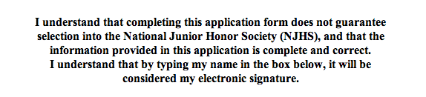

Candidate Name/Signature:
Date:

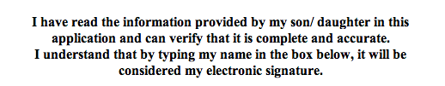

Parent/Guardian Name/Signature:
Date:

**The entire application packet is due to Ms. Kreiser NO LATER than Thursday, February 28th, 2018 at 2:45PM - NO EXCEPTIONS**

AFTER YOU SUBMIT YOUR APPLICATION, YOU SHOULD RECEIVE AN EMAIL FROM MS. KREISER CONFIRMING THAT SHE RECEIVED YOUR APPLICATION. IF YOU HAVE NOT RECEIVED AN EMAIL STATING THAT YOUR APPLICATION PACKET HAS BEEN RECEIVED WITHIN 24 HOURS, PLEASE WITHER EMAIL MS. KREISER OR SEE HER IN THE LIBRARY.

